Pie-oneer Design Document

Product Summary 2

Vision 2

Mission 2

Target User / Needs 2

Features 2

Architecture 3

Boundaries 3

Project Community Interactions 3

Committed Resources 3

Prospective Analysis 3

Opportunities 3

Threats 4

Feature Designs 4

Detailed Design 5

Team Details and Links 5

Sprints 6

Change Log

|  |  |  |
| --- | --- | --- |
| Who | What Changed | Date |
| Whole Team | **Initial Document** | 11/12/2021 |
|  |  |  |

# Product Summary

## Vision

A retro dungeon style video game that is made to appeal to players that enjoy humorous and dark role-playing games. Its 8-bit top-down style of gameplay will bring nostalgia to 90’s and early 2000’s players.

## Mission

### Target User / Needs

* Mark – 90’s Video game enthusiast – Wants to play a video game that reminds him of older 8-bit video games.
* Sam – Admin – Wants to fulfill older gamer’s desires of a fun 8-bit video game.

### Features

* Dungeon maps that the player is free to explore in.
* NPC’s spread throughout the dungeon that will give the player hints about the dungeon they are in.
* Player health bar will be included in a noticeable position, so the user can keep track of his health.
* Item bar will be included, so the player can see all of their possessions that are equipped and switch between items.
* The game will include creatures that will randomly spawn and attack the player while they try to solve the dungeon.
* As the player progresses, new weapons will be unlocked for the player to use.
* Humorous and dark story that will be enjoyable for the player

# Architecture

|  |  |
| --- | --- |
| **Technology / Layer** | **Tool / Version** |
| Data Layer | JSON - TBD |
| Presentation Layer | Unity Editor - 2020.3.21f1 |
| Service Layer | Unity Engine - 2020.3.21f1 |

Unity Editor

Unity Engine

Database (JSON – TBD)

C# - .NET 4.6

# Boundaries

## Project Community Interactions

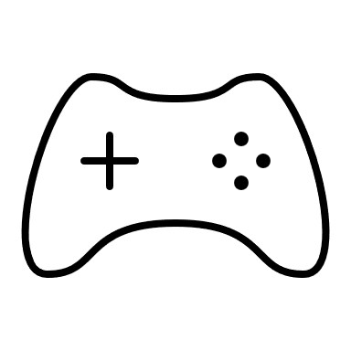

Pie-oneer Game

Wants To Play a Video Game

Sam

Sam wants to play an older style video game. He then chooses to play the Pie-oneer video game as this resembles the game he wants to play.

## Committed Resources

Azure DevOps, Unity Editor, Discord, Visual Studio, TortiseGit

## Prospective Analysis

### Opportunities

|  |  |  |  |
| --- | --- | --- | --- |
| # | Opportunity | Likelihood (1-5) | Benefit (1-5) |
| 1 | The team knows individuals who are willing and wanting to play the game for testing. | 5 | 5 |
| 2 | Get people to draw the in-game art for our characters | 2 | 3 |
|  |  |  |  |

### Threats

|  |  |  |  |
| --- | --- | --- | --- |
| # | Threat | Likelihood (1-5) | Impact (1-5) |
| 1 | We are learning how to communicate as a team and understanding each other’s personalities. | 3 | 4 |
| 2 | Learning Unity is a work in progress. | 4 | 5 |
| 3 | Still learning databases and how to apply them. | 2 | 4 |

# Feature Designs

N/A

# Detailed Design

## Team Details and Links

**Team Organization / Project(s):**

https://dev.azure.com/OITJuniorProject-Pie-oneer/Pie-oneer

**Project Code:**

N/A

**Project Tests:**

N/A

**Other:**

N/A

## Sprints

#### Sprint 3

1. What changes to in the high-level design occurred last sprint? (Note it here, update the design and fill the change log.)

None

1. What is your strategy or goal for this sprint? (short)

Our goal for this next sprint is to finish designing the game, having our individual workstations connected to the project with all resources working properly, and begin implementing a scene for the game that is interactable.

1. Describe any trade-offs and alternatives that you expect to encounter.

None

1. How will you maintain team code ownership?

* Each individual will have their own individual user story that will have their own code applied to.
* At the top of each file, we will make sure to comment when that file was worked and by whom.
* We will communicate through discord when we will be pushing or pulling code and what changes were made.

1. Other questions that you add based on your domain.

None